# Pressure Tank Report

This report is explanation of the calculations and Measuring the distance of the pressure tank gun we are building.

# Prerequisite to the report

We are making a water gun that needs to shoot at least 6 meters. Therefore, we have bought a pump that Tolga and Nikita are testing, but to explore more options, we are currently trying to build a reverse bottle rocket, where we hold the bottle part still, and shoot out water.

We have a goal of making the bottles hold 50PSI of pressure, that would have a exit velocity of 22m/s according to Radu’s calculations of the bottle. You can see the calculations here:

Et billede, der indeholder tekst, håndskrift, blæk/sværte, papir

Indhold genereret af kunstig intelligens kan være forkert.

# First and second try

Our first try we build them like you would normally a bottle rocket, where we tried to just glue the valve and the one-way valve for the pressurization. Here is the pictures and a small explanation off why it didn’t work:

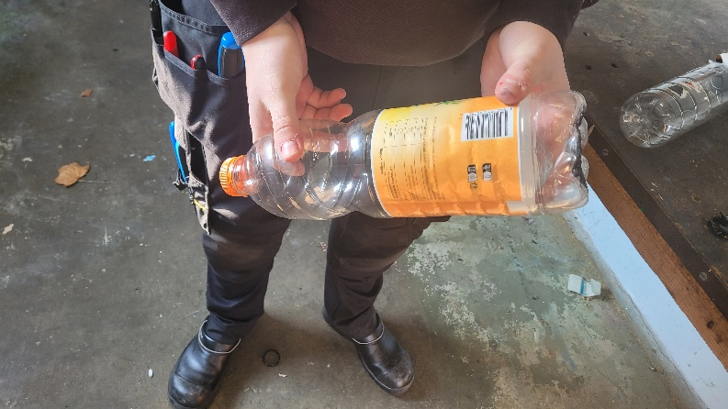Et billede, der indeholder maskine, Metalarbejde, bore/bor, Maskinværktøj

Indhold genereret af kunstig intelligens kan være forkert.

Et billede, der indeholder værktøj, person, Maskinværktøj, jord

Indhold genereret af kunstig intelligens kan være forkert.

This was all very great, the idea was good, but the execution was a bit off. It did hold the pressure up until 10PSI. but after that it blew out the glue from the cap. This was because the glue doesn’t stick on “fatty plastics” which this is, because it’s made from PP (polypropylene), and PET (which is the rest of the bottle) is not a fatty plastic. Meaning the glue stuck great for the one-way valve, but the release valve was not good.

Therefore, we decided to make a bottle that only was glued on the PET bottle.

This looked like this:

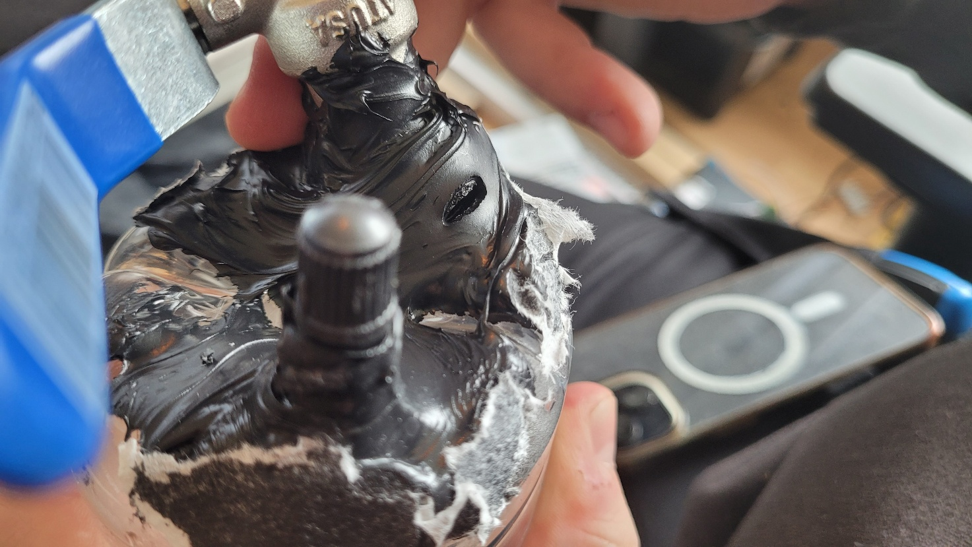

Et billede, der indeholder person, indendørs, blender, Laboratorieudstyr

Indhold genereret af kunstig intelligens kan være forkert.

This was a bit better at a whopping 12PSI of pressure before bursting the glue open, spewing water everywhere. This was better, but still not ideal. Therefore, we were thinking a bit outside the box. We tried to sketch up ideas of welding a steel pressure tank together. Usually, the only steel tanks that we could buy would be rather heavy (exciting the weight of max 11kgs) and have a very large capacity, which was not needed.

Therefore we looked into other types of tanks;

# Pressure tanks made from PVC pipe.

We took a lot of inspiration from different sources, but the thing we were looking at was other people successfully storing 80-120PSI of pressure in air cannons, the concept looking very similar to what we are building. The main youtube video “guide” we follow was this;